Fridley School District
6000 West Moore Lake Drive
Fridley, Minnesota 55432
Phone: 763-502-5000

Instructions for setting up your students TIES feePay account:

Website: https://fridley.feepay.com/

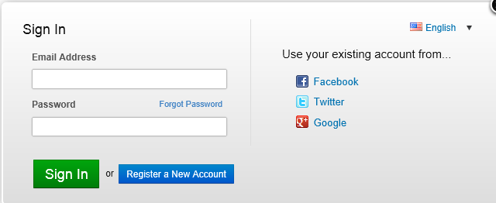

- Register a new account using existing Facebook, Twitter, or Google account.

- Or register a new account by using your email address.

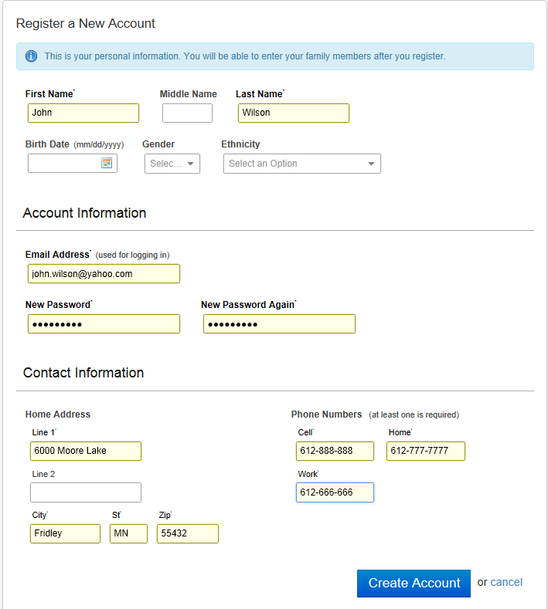

To add your students use the “Add Family Member” button:

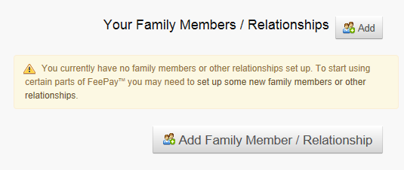

When setting up your student you must select: “Yes, They Have A Student Id”

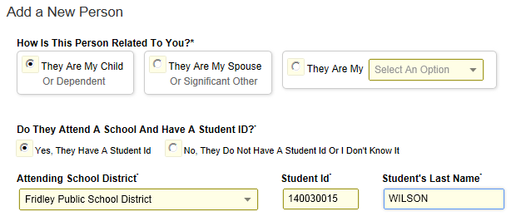

Your student’s ID # is located at the top of your student’s schedule

13-14  Fridley High School  6000 West Moore Lake Drive, Fridley MN 55432  Generated on 08/12/2013 02:08:17 PM | Student Schedule for Wilson, John M  Grade: 12 Student Number: 00140030015 **  Courses enrolled: 19  Mailing Address: 6200 Riverview NE, Fridley, MN 55432

** Important if the student number has leading zeros do not enter the leading zeros.
(Example 00140030015 should be entered 140030015).

